TypeScript

Lab Book

Document Revision History

|  |  |  |  |
| --- | --- | --- | --- |
| Date | Revision No. | Author | **Summary of Changes** |
| March 2018 | 1 | Rahul Vikash | Created new lab book as per course contents |
|  |  |  |  |
|  |  |  |  |
|  |  |  |  |

Table of Contents

*Getting Started..……..…………………………………………………………………………… 4*

Overview 4

Setup Checklist for AngularJS 4

Instructions 4

Learning More 4

*Lab 1. TypeScript Angular 5*

*Appendices………………………………………………………………………………………… 11*

## Appendix A: Table of Figures ………………………………………………………… 11

Getting Started

## Overview

This lab book is a guided tour for learning Angular 2.0 For JEE version and above. It comprises ‘To Do’ assignments. Follow the steps provided to work out the ‘To Do’ assignments given.

## Setup Checklist for Typescript

Here’s what is expected on your machine for the lab in order to work.

Minimum System Requirements

* Intel Pentium 90 or higher (P166 recommended)
* Microsoft Windows XP, Windows 7 or Windows 8
* Memory: 2GB of RAM (1GB or more recommended)
* Google Chrome 36.0 or Mozilla Firefox 31.0 or Internet Explorer 10 or above

Please ensure that the following is done:

* A text editor like Notepad or Notepad++ or Eclipse Luna is installed.
* Node.js install with node module

## Instructions

* Create a directory by your name in drive <drive>. In this directory, create a subdirectory angular_assgn. For each lab exercise create a directory as lab <lab number>.
* You may also look up the on-line help provided in https://v2.angular.io/docs/ts/latest/guide/setup.html

## Learning More

1. Typescript Angular Components & Data Binding

|  |  |
| --- | --- |
| Goals | * Understand the typescript |
| Time | 60 minutes |
|  |  |

* 1. Create Typescript class ,as per below mentioned diagram

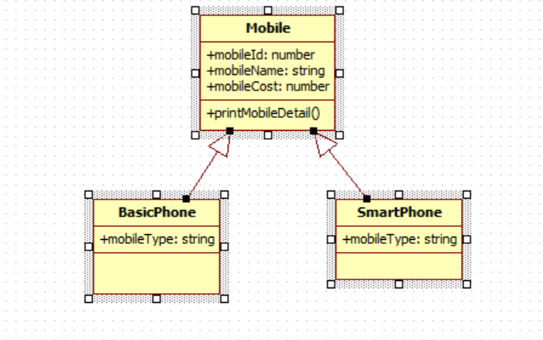

All 3 classes are in separate file. We have to add mobile details such as id, name, cost & type from different typescript file & print data in console

1. Get Data from array

## Appendix A: Table of Figures

Figure 1 5

Figure 2 5

Figure 3 6

Figure 4 6

Figure 5 7

Figure 6 8

Figure 7 8

Figure 8 8

Figure 9 9

Figure 10 10

Figure 11 10